Name of the Experiment:
Combinational and Sequential Circuit Implementation Using iVerilog.
Theory:
Decoder: Decoder is a combinational circuit that has ‘n’ input lines and maximum of 2^n output lines. One of these outputs will be active High based on the combination of inputs present, when the decoder is enabled. That means decoder detects a particular code.
Truth table of a 2 to 4 decoder is given below:
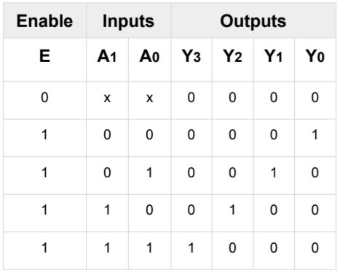
D-Flip Flop with Synchronous Enable: A D flip-flop, or Data flip-flop, is a type of digital storage element used in sequential logic circuits. It captures the value of the D input (data) at a specific portion of the clock cycle (usually the rising or falling edge of the clock signal) and holds that value until the next clock edge. A D flip-flop with a synchronous enable (often referred to as a D flip-flop with an enable or D flip-flop with a clock enable) is an enhanced version of the standard D flip-flop. It includes an additional input, the enable signal (EN), which controls whether the flip-flop should update its state on the clock edge or maintain its current state.
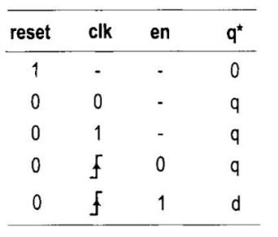
Source Code:
Decoder:
HDL Code:
module decoder2to4
(
input [1:0] A,
input E,
output [3:0] Y
);
assign Y[3] = E & A[1] & A[0];
assign Y[2] = E & A[1] & ~A[0];
assign Y[1] = E & ~A[1] & A[0];
assign Y[0] = E & ~A[1] & ~A[0];
endmodule
Testbench:
`timescale 1ns/1ps
module decoder2to4_tb;
reg [1:0] A;
reg E;
wire [3:0] Y;
decoder2to4 uut
(
.A(A),
.E(E),
.Y(Y)
);
initial begin
$dumpfile("test.vcd");
$dumpvars(0,decoder2to4_tb);
A[1] = 0;
A[0] = 0;
E = 0;
#20;
E = 1;
#20;
A[0] = 1;
#20;
A[1] = 1;
#20;
A[0] = 0;
#20;
end
initial begin
$monitor("E=%d A[1]=%d A[0]=%d Y[3]=%d Y[2]=%d Y[1]=%d Y[0]=%d\n",E, A[1], A[0], Y[3], Y[2], Y[1],Y[0]);
end
endmodule
D Flip Flop:
HDL Code:
module d_ff
(
input wire clk,
input wire reset,
input wire en,
input wire d,
output reg q
);
always @(posedge clk, posedge reset)
begin
if (reset)
q <= 1'b0;
else if (en)
q <= d;
end
endmodule
Testbench:
`timescale 1ns/1ns
module d_ff_tb;
reg clk;
reg reset;
reg en;
reg d;
wire q;
d_ff circuit1
(clk, reset, en, d, q);
always begin
clk = ~clk;
#10;
end
initial begin
$dumpfile("test.vcd");
$dumpvars(0, d_ff_tb);
clk <= 0;
reset <= 1;
en <= 0;
d <= 0;
#20;
reset <= 0;
en <= 1;
d <= 1;
#20;
$finish;
end
initial begin
$monitor("clk = %b, reset = %b, en = %b, d = %b, q = %b", clk, reset, en, d, q);
end
endmodule
Output:
Decoder:
Terminal Output:
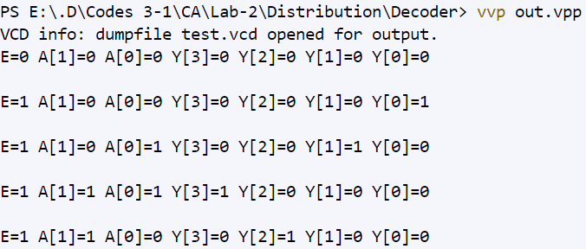
GTKWave output:
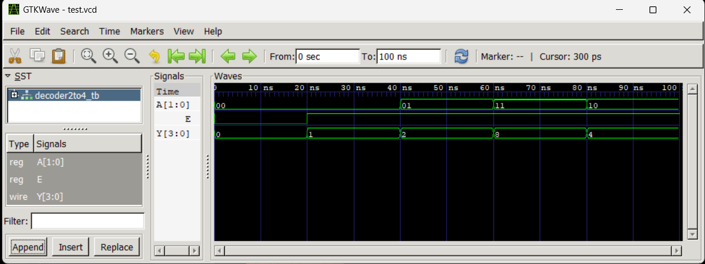

D-Flip Flop:
Terminal Output:
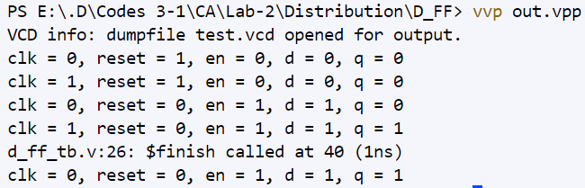
GTKWave:
